**GITHUB STEPS APPLIED**

First of all a reprository is created and the project document file and the ipynb notebook is uploaded to reporsitory. The screenshot of created repository with files uploaded is attached below:

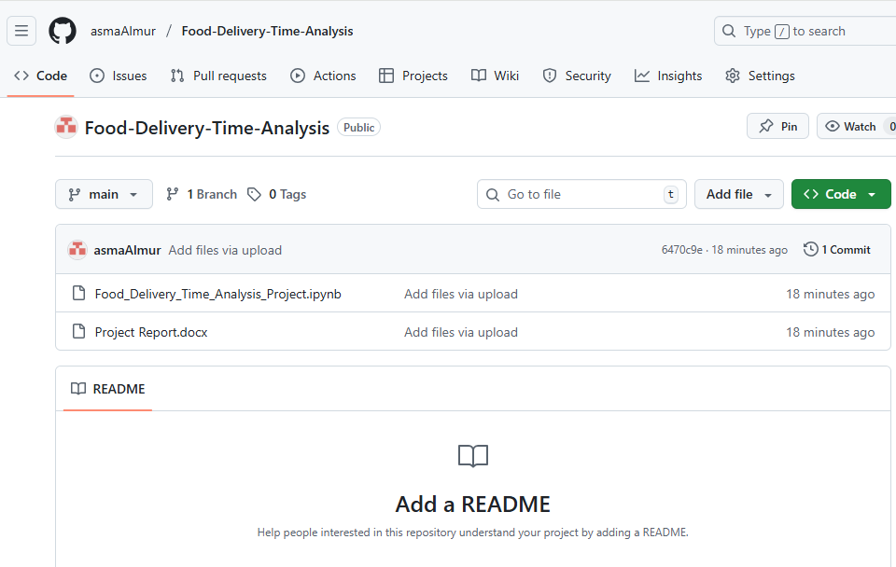

Next, in the terminal, we cloned our github repository and moved to the directory of our project. The files from the repository are pulled.

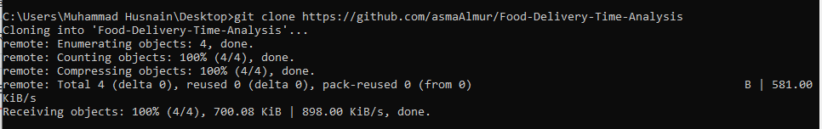

But before that, a personal access token is extracted which is shown in the screenshot attached below:

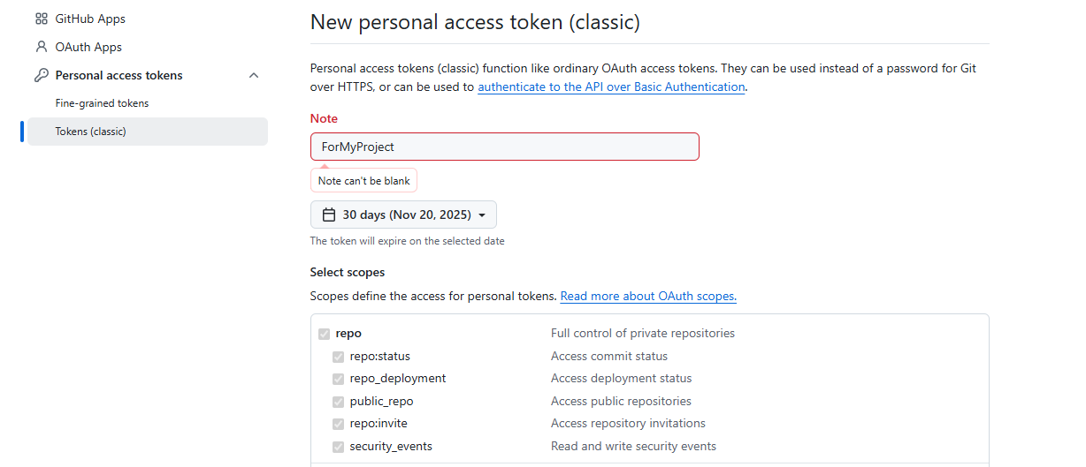

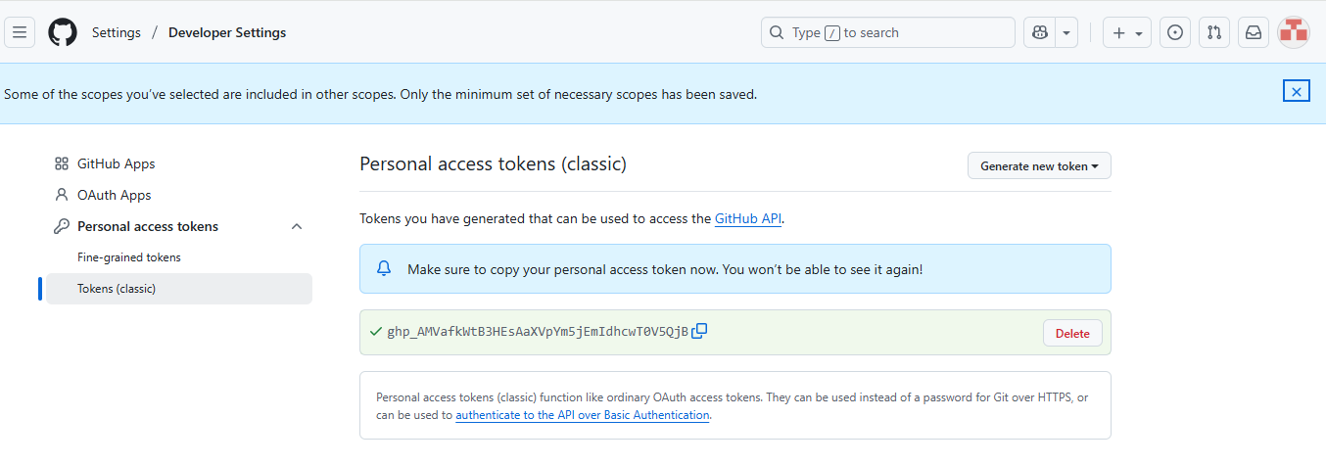

The file is slightly modified and pushed back to the repository. When pushing back it asked for the PAC we extracted from the github.

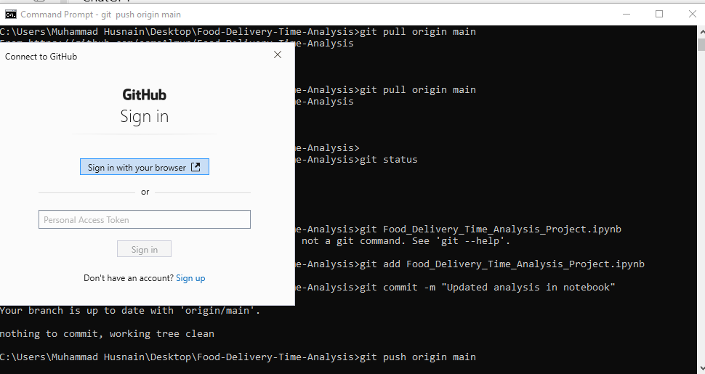

Once the PAT is entered the files are pushed to the repository.

